**O Canada: Our national anthem and Robert Stanley Weir’s Memphremagog muse**

*Jeffrey Packard and Stephen W Simpson*

O Canada, our national anthem, is Canadian. This apparently absurdly self-evident and redundant statement, does not however refer to ownership. The matter of title was decided in 1980 by an act of parliament. O Canada is most certainly owned by Canadians. However it is also quintessentially Canadian by its nature and origins. Like the nation it seeks to reflect and honour, it is a most curious (but we would argue successful) amalgam. Its title is aboriginal (St. Lawrence Iroquoian), its musical score was composed by a very talented French-Canadian musician and nationalist, Calixa Lavallée, who lived a good part of his life in the US, and its french and english lyrics were penned by jurists, Adolphe Basile Routhier and Robert Stanley Weir, respectively. All three men were equally at ease in both languages and both cultures. Originally this national song was presented to the dominion-wide convention of French-Canadiens held in 1880 in Quebec City hosted by the Société Saint Jean Baptiste. Routhier’s paternal family roots stretch back to 1700 in New France, and his lyrics reflect the proud history of French Canada and a resolute Catholic faith. It was premiered on June 24th by a combined three bands conducted by Joseph Vezina, and fittingly perhaps, was staged in the newly constructed Quebec City hockey arena. It was received with significant enthusiasm but only started becoming quite popular in French Canada after 1900.

Weir, a first generation Canadian born in Ontario but raised in Quebec, wrote his English lyrics in 1908 in association with the tricentenary celebrations of the founding of Quebec. His words appeal to a more secular patriotism and an abiding identity with the “True North”.

This article concerns the Hon. Robert Stanley Weir K.C., D.C.L., F.R.S.C. (1856 – 1926), and in particular his relationship to the Lake Memphremagog region of the Eastern Townships. Despite humble beginnings Robert was destined to lead a very productive and varied life. He was from the outset a prodigious learner, and excelled in law, music and literature. He was a teacher, principal, lawyer, church organist, essayist, poet, failed politician, choir director, music teacher and arranger, golf enthusiast and jurist. Fluently bilingual, he was appointed Recorder for the City of Montreal in 1899 and became a Judge in Admiralty of the (Federal) Exchequer Court of Canada in 1925.

He was passionate about this country, but the particular spot in the vast dominion closest to his heart was the tiny hamlet of Cedarville (near Stanstead) in the Eastern Townships of Quebec, about 1 km north of the US-Canada border. It was here at his summer home on Lake Memphremagog in July of 1908, whilst the Tercentenary celebrations were taking place in Quebec City, where Weir started to write the words to our national anthem. The reasons for doing so were both deliberate and circumstantial. Weir had been involved in the Tercentenary planning and fund raising, and as a patriotic and literary Canadian he may well have wished to contribute verse to further promote the official undercurrent of the festivities, that is, pride in, and reconciliation between, the two founding races. Enter his friend and fellow summer resident of Cedarville, George A. Grant-Schaefer. George was a Canadian musician and arranger who taught in Chicago. That spring, in Chicago, he had heard a truly inspiring march played by a Canadian military band from Toronto. He didn’t recognize it but the tune couldn’t be dislodged from his head. At the Lake he hurried over to Weir’s place to see if the Judge could identify the music. Of course Robert immediately recognized the airs of Lavallée’s wonderful melody. Grant-Schaefer then proposed to Weir to write english lyrics to the tune. Weir agreed, then quickly demanded of George that he fashion a new and fresh arrangement for Lavallée’s composition. The product of their collaboration was finished by the Fall.

..........But perhaps we should start at the beginning. Robert was born in 1856 of working class Scottish immigrant parents. The Weir family moved from Hamilton (then Canada West) to Montreal around 1858, when young Robert was two. His father, William Park Weir, was originally an iron founder, and the family was probably drawn to Montreal due to construction of the Victoria Bridge. They settled as tenants in Griffintown, the predominantly Irish Catholic working class neighbourhood that lay just west of the Port, and north of the Lachine Canal, where both light and heavy industries were then concentrated.

This is where Robert and his 5 siblings grew up. His father started working for Canada Customs in 1862, originally as a clerk, and ultimately as Tide Surveyor and Surveyor of Shipping. The circumstances of the family gradually improved and the last family residence was at the corner of Cote St. Antoine Road and Dorchester, in what was then the village of Notre Dame de Grace. William Park died of a stroke in 1889.

As a child Robert (“Bert”) was evidently a very bright and talented lad, and at home, learning was very much encouraged. The Scots as a rule greatly valued education so it is somewhat ironic that at age 11 Robert was taken out of elementary school to work as an office boy (for $1.50/week !). His father felt it was a waste of his son’s abilities to be taught in the neighbourhood school, rudiments of subjects, in which he was already completely proficient. Fortunately in the Fall of 1869 Ernest Manley Taylor (who taught Robert, and was perhaps best known as a noted Eastern Township historian), persuaded William Park to enroll Robert in the McGill Normal School.

The only space available was in the senior division, but despite his youth he excelled. He was admiitted at age 14 into Teacher’s Training, and graduated with a diploma at 15. After a few years teaching he became the principal of the Sherbrooke Street Commissioner’s School at age 19. While employed in the educational realm, Robert pursued and obtained in succession, an M.A. and then a Bachelor’s of Law at McGill. He was called to the bar in 1881. His passion for learning did not stop there. While working as a lawyer he also obtained a Bachelor’s of Music (Bishop’s) and a Doctorate of Civil Law (McGill), and found time to help revise the charter of the City of Montreal.

In May of 1899 Robert Stanley Weir was appointed Recorder for the City of Montreal, a position he would hold until June of 1915 when he resigned to return to private law practice.

In 1882 he married Margaret Douglas (“Gertie”) and it was through his in-laws that Dr. Weir was introduced to the Lake Memphremagog region. In the summer of 1896 his widowed mother-in-law assembled all her offspring with their families for a reunion. They decided to rent the Cedarville Inn, which was at that time little used by its owners, the Covells from New York. Bert and Gertie were entranced by the locale, and in 1900 they managed to buy the old inn, which they renamed Cedarhurst. For the next 26 years the Weir family enjoyed their home-away-from-Montreal in all seasons, but for obvious reasons, mostly in the summer.

In some respects, present-day summer lakeshore residents, would easily identify with life at the Lake in the late 1890's.

The Weirs loved boating, and exploring, and reading by the Lake with the waves lapping nearby. Tennis, photography, gardening, and pitch and putt golf were embraced by various members of the clan. Robert in particular was a golf enthusiast and although there was no local club within horse and buggy distance (Dufferin wasn’t founded until 1922), there are many photos of Bert at Cedarhurst practising his swing. One year he won the Canadian men’s senior championship. The Weirs had a flotilla of boats, including a sailboat and a power boat (actually a steam yacht), and a number of canoes and rowboats.

Apparently Bert loved revelling in the history of the place, and hearing from the more elderly locals, stories of adventures on and around the Lake. As there is today, there were always chores to be done, distributed in some fashion amongst the six Weir children.

In other respects it was quite a different experience. In the beginning, they were literally the only summer residents for miles around, although starting in about 1904 a mini-boom in cottage development was to begin. Just getting to and from the Lake was a major expedition. It was generally easiest to take the train to Newport, and then take a boat from there to Cedarhurst.

Weekend excursions to the country simply didn’t happen. Once the family was installed, they were generally there for some time. Of course communication was restricted to letter-writing and food and milk were courtesy of local farm families. Well water was hand pumped. A horse and buggy ride into Beebe would take about 50 minutes one-way. Daily train passenger service on the Maine Central (formerly Massiwippi Valley Railroad) was available from Lineboro (to Sherbrooke or Newport, thence by connecting trains to Montreal).

In 1912, in conjunction with his eldest son Douglas who had trained as a microbiologist at the Ontario College of Agriculture at Guelph, the Judge bought the late George Hall’s farm from his estate. Bert became a (very) part-time gentleman farmer! He and Douglas were also interested in silviculture and both were active members of the Forestry Association.

The Law was Judge Weir’s vocation for most of his adult life, but music, literature and theatre were his passions. During his holiday times at the Lake he had opportunities to indulge in these interests. Each summer Cedarhurst staged a single-performance play and all able-bodied children and young adults were expected to participate. Choreography, musical interludes, choral arrangements, stage management were all guided by the talented Mr. Weir.

Robert Stanley Weir’s love for the Lake Memphremagog region is most profoundly expressed in his poetry. Two volumes of his poems were published, After Ypres (1917), and Poems: Early and Late (1922), and many others were published in newspapers and magazines. It was his poetry that led to his becoming a Fellow of the Royal Society of Canada. Of some 81 poems the family files retain, many of them make mention of the Lake, and three are entitled Memphremagog. The verse is certainly of its age, Edwardian in tone, romantic in spirit, and filled with lovely metaphors, literary allusions and biblical references. The subject matter ranges greatly, but it is clear that the carnage of, and the courage displayed in, the Great War, as well as the death of Douglas, his eldest, had a profound impact on Robert. His poetry writing must have served as some solace in his grief. In both poems below, it is clear that Robert feels that the Lake has the capacity to pacify the soul, and to serve in eternal remembrance.

***Lake Memphremagog 1922***

*Here are no legends of dark history,*

*No echoes of war bugles, fifes or drums;*

*Only the ever lovely mystery*

*Of how the glory of summer comes;*

*No clamour, neither, save a shouting loud*

*When on the mountain breaks a thunder cloud;*

*Then we, who weep not lest we cause them pain,*

*Welcome the lamentation of the rain;*

*Legends not old, but new, that whispering tell*

*Of ten tall youths who knew these waters well:*

*Swam them and sailed them and from mountain height*

*Watched the gray eagle’s solitary flight:*

*Whom we shall see no more until we join the Dead;*

*Who lie far hence, with Christ’s cross at each head.*

*Thou now art spirit-haunted, lake, and this*

*Gives thee a solemn glory kin to bliss,*

*As we remember Them, and brood and pray,*

*Till the day break and shadows flee away.*

***Lake Memphremagog***

*O Memphremagog, sea diminuitive!*

*The beauty of the Trosachs bides with thee,*

*Although not thine the highland wizardry.*

*Nor doth the dweller by thy shores receive*

*The solemn thrill Gennesaret doth give;*

*Nor yet the subtle charm that ever breaks*

*From the old glory of Italian lakes,*

*And Windemere, where Wordsworth still doth live.*

*But thou hast spell for peace that is thine own.*

*Long long ago the untamed Iroquois*

*Mounting Owl’s Head or Elephantis, saw*

*Thy shining beauty in the distance lone.*

*His heart stirred strangely as, entranced he stood;*

*Grew soft awhile, -forgot its thirst for blood.*

In the period 1922 to 1924, Robert Stanley suffered at least two minor strokes (like his father before him) which impacted his speech and ability to play the piano. From both episodes he fought back valiantly and recovered much of his lost abilities. Certainly his intellect and judgement were never compromised, for in March of 1925 he was appointed Judge in Admiralty of the (Federal) Exchequer Court of Canada, of which body he became President. In the summer of 1926, never one to lose an idyl moment, Robert was working on the staging of the Antigone of Sophocles with Mendelssohn’s music to celebrate the opening of the New Moyse Theatre at McGill. Unfortunately, this was not to be. Judge Weir died of pneumonia at his beloved Cedarhurst on August 20th, 1926.

Sir Andrew MacPhail wrote of RSW after his death,

*“it can be truly said he was just in the exercise of power, generous in the protection of weakness, and beloved for his charm of kindly courtesy to timid souls of all classes.”*

**Illustrations**

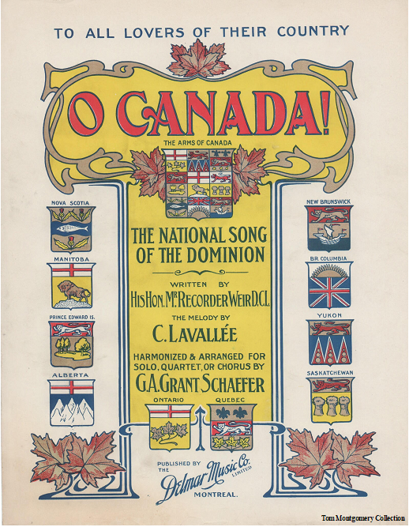

***Front page of sheet music of O Canada as published in 1908***

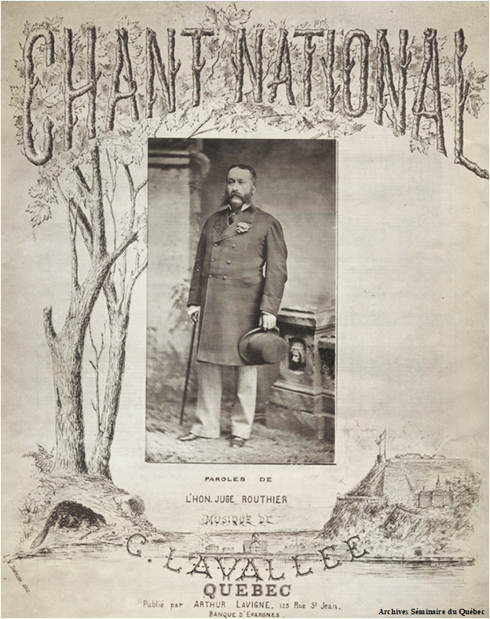

***Front page of the music sheet for the Chanson Nationale as published in 1880, music by Calixa Lavallee, words by Judge Routhier.***

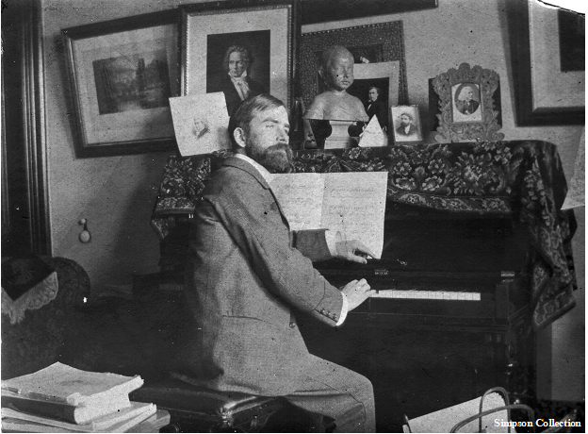

***Robert Stanley Weir at his piano in Montreal***

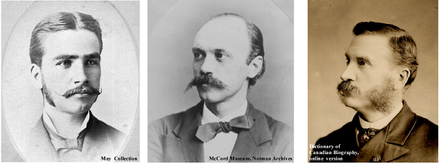

***Robert Stanley Weir c. 1881, age 25. Calixa Lavallée c. 1876, age 37. Adolphe-Basil Routhier c. 1881, age 45.***

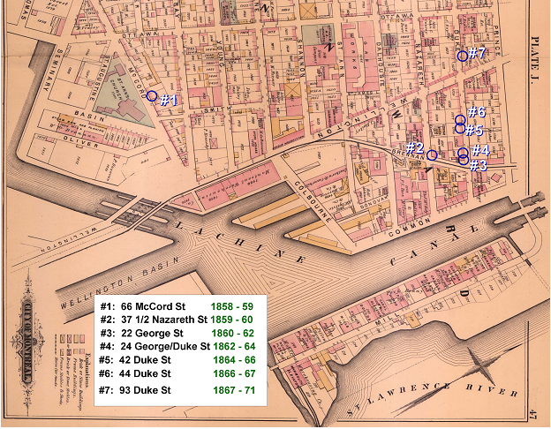

***As tenants the Weir family moved every 1 or 2 years to different flats in Griffintown, partly due to their ever increasing number of children.***

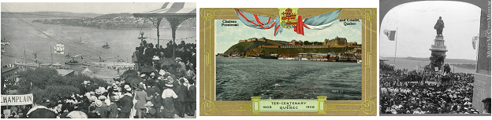

***Crowds gather on Dufferin Terrace as a replica of Champlain’s Don de Dieu approaches the shore***

***Postcard celebrating the Quebec City Tercentenary in 1908***

***Celebration crowd at Champlain’s statue, Quebec City, 1908***

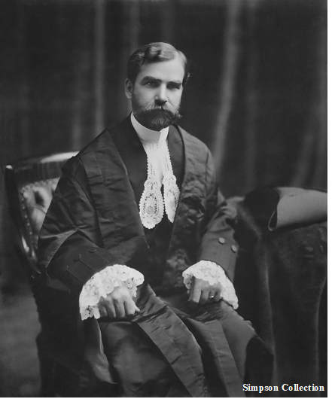

***Robert Stanley Weir in 1899, Recorder for the City of Montreal***

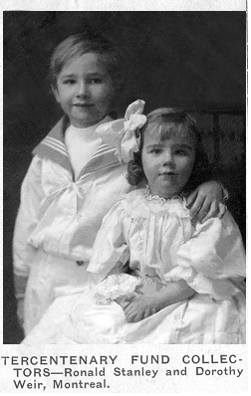

***The two youngest Weir children, Ronald and Dorothy, are put to work raising money for the Tercentenary Fun***

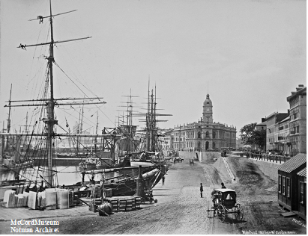

***View towards the west from the Port of Montreal, towards Griffintown. Building with tower is the “new” Customs Building where William Park Weir worked.***

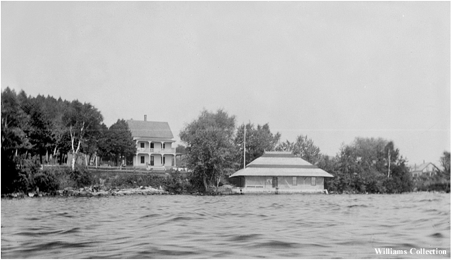

***“Cedarhurst” in 1896 prior to its purchase by the Weirs***

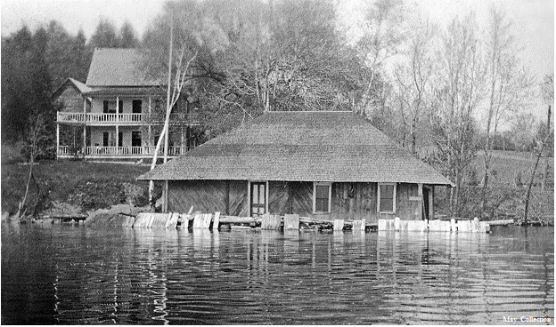

***View of Cedarhurst from the water, Spring of 1919***

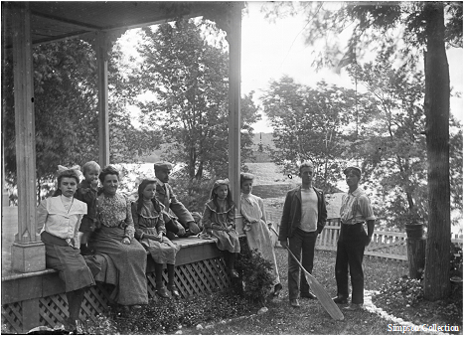

***A family gathering on the western end of the large porch that wrapped around Cedarhurst. L to R, Maude Weir (a cousin), Ron, Gertie, Winifred, Robert, Marjorie, Beatrice, ??, Douglas***

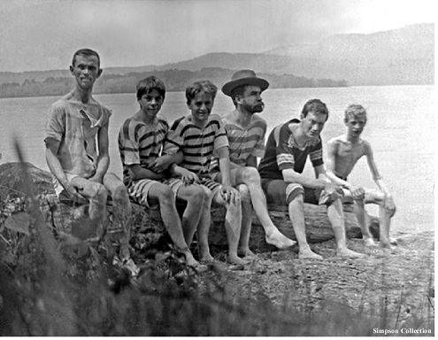

***Modesty demands a hat! The Judge with various Douglas in-laws in vicinity of Weir Park; Bear Mtn in background.***

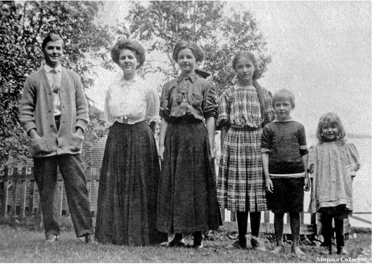

***The Weir children at Cedarhurst in 1908. From left to right, Douglas (1883-1918), Beatrice (1885-1949), Winifred (1893-1950), Marjorie (1895-1961), Ronald (1901-1944), and Dorothy (1903-1964).***

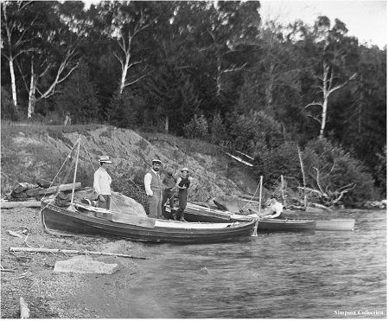

***Commodore Weir and others, with part of the “fleet” aground on some Lake Memphremagog beach, circa 1900.***

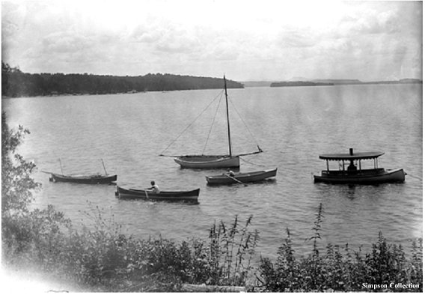

***The Weir Grand Fleet at anchor in front of Cedarhurst, circa 1900***

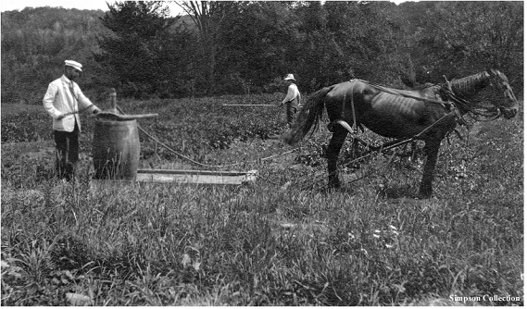

***The impeccably-dressed Judge does farm work at Cedarhurst farm, circa 1913.***

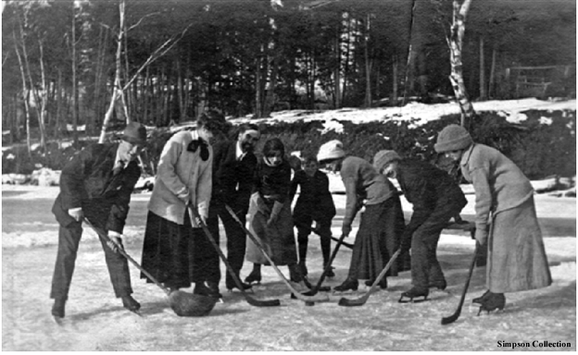

***Christmas holidays were sometimes taken at Cedarhurst. The old inn must have been very cold. This photo was taken in December of 1912 and shows a game of pond shinny about to commence. Makes one wonder if they sang O Canada to start the game?***

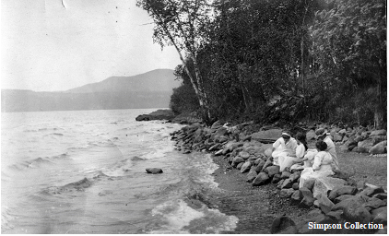

***Two views taken on the same day on the shoreline in front of Cedarhurst, on the left a view to the west and Bear Mtn., and on the right towards the east and the Cedarhurst boathouse. Bert and Gertie are present along with their daughters Winifred and Marjorie.***

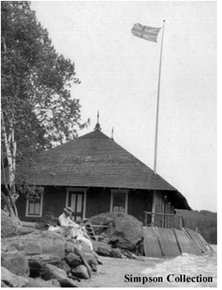

see above caption

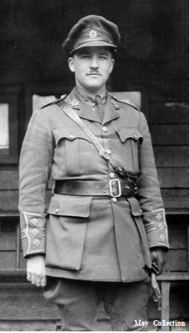

***Captain Douglas Weir, the Weir’s eldest son. (1883-1918)***

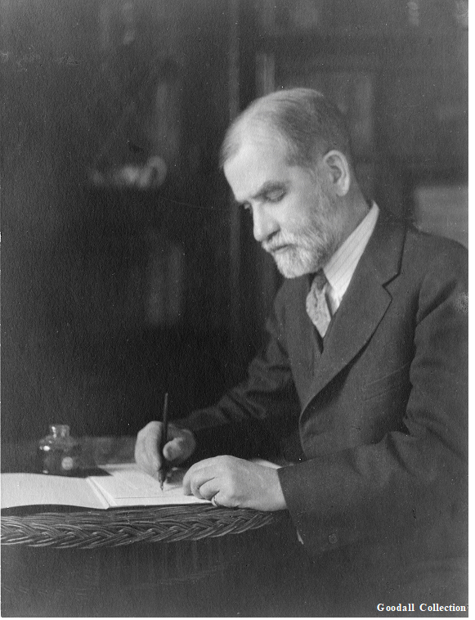

***Judge Robert Stanley Weir***